SPH4U Sample Question- Finding Net Force on an Object

Steps:
- Choose an x/y coordinate system.
- Resolve each force in the x/y directions
- Write a net force statement in each direction.
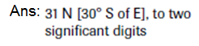
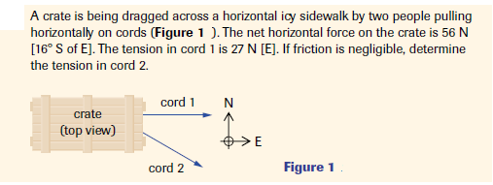
- Identify the net force condition in each direction (Fnet= ma OR Fnet= 0).

Net Force Textbook Questions- Unit Outline Day 3: Sect. 2.1 P1,2,5 pg. 68 S6,8,9 pg.69

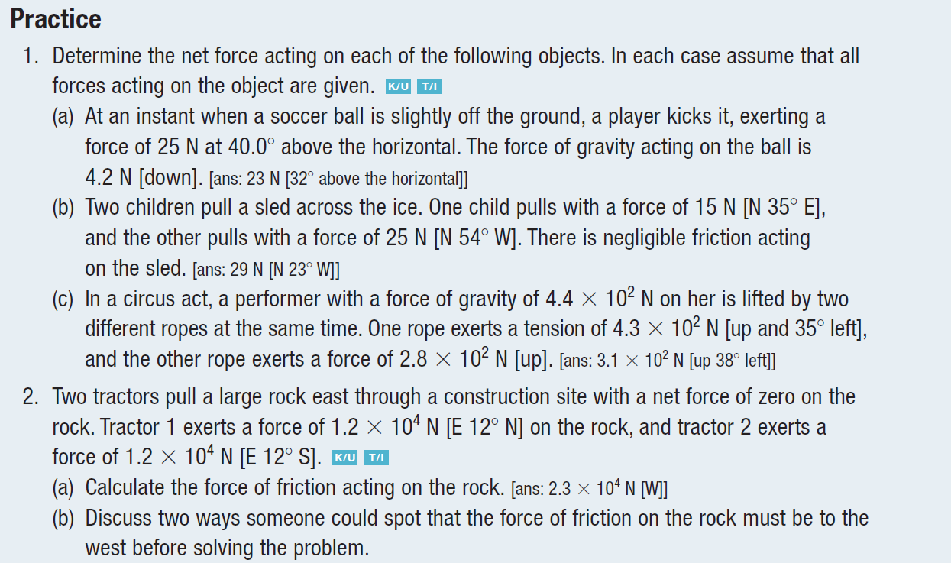

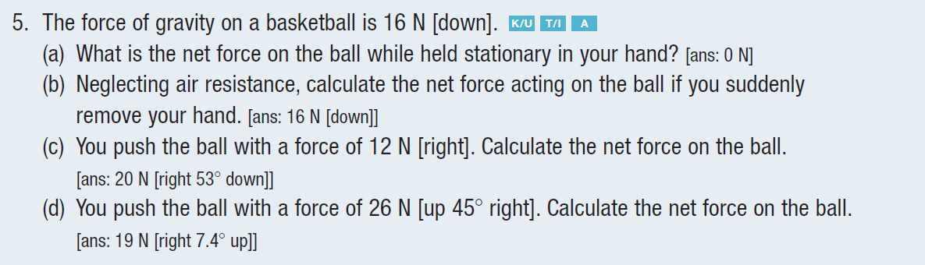

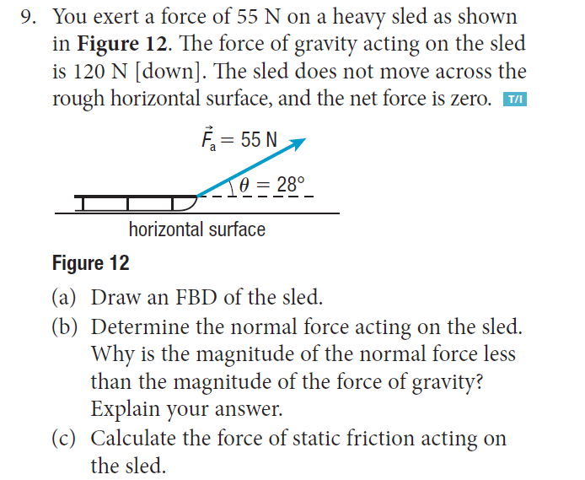
Section questions:
